Chapter 5, Solution 37.

Determine the output of the summing amplifier in Fig. 5.74.
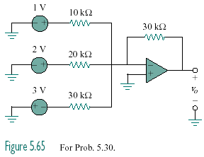

2 V

–2 V

4.5 V

Figure 5.74
For Prob. 5.37.

Solutio

v_{o} = 1.5 V.

